Jyle Darling

M093437

Software Deployment project

AT2

Table of Contents

Activity One Requirements 1

Development Methodology 1

Project Plan 1

Source Control 1

Collaboration Environment 2

SQL Statements 2

Activity Two Requirements 3

Installation Method and Plan 3

System Requirements 3

Installation Package Development 4

Demonstration of the Application Installation 5

Demonstration of the Application Uninstallation 5

Database Deployment 5

Application Configuration 5

Security Features 5

# Activity One Requirements

### Development Methodology

Due to the relatively simple requirements of this application and the requirements all being provided upfront, I think a waterfall method would be best suited for this software development life cycle choice. This application should easily be developed within a week by a single programmer.

### Project Plan

I have opted to use Microsoft Project to develop the project plan for this application’s development process. This program has been selected due to my previous experience. Another option would be Project Libre, as it is a free software that mimics a lot of the functionality that Microsoft Project provides. An image of the project plan will be depicted below, as well as being available in the project repository, which I will go into further detail.

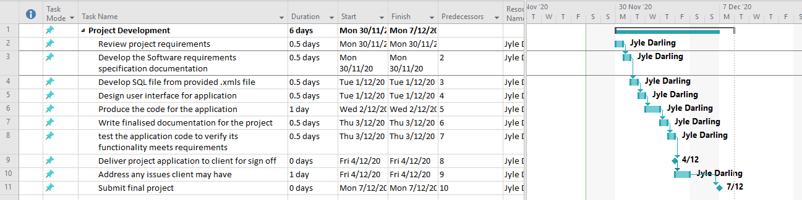

### Source Control

For this project, all code files and documentation will be stored on GitHub as the chosen repository for the development of this application. I have chosen GitHub for much of the same reasons as above, in that I am familiar with the using the software, and it its free to users. Below is an image of the source control, which can also be found at: <https://github.com/Jely101/Software-Deployment-Project>

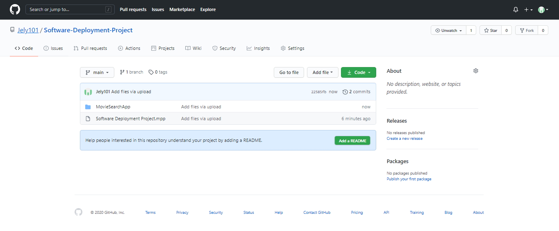

### Collaboration Environment

I have chosen to use GitHub for the collaboration of the applications development, due to it being easily accessible from the repository’s location, not to mention my previous familiarity with this collaboration tool and the fact it is free to use. a snapshot of the collaboration environment can be found below, and can be viewed at anytime at: <https://github.com/Jely101/Software-Deployment-Project/projects/1>

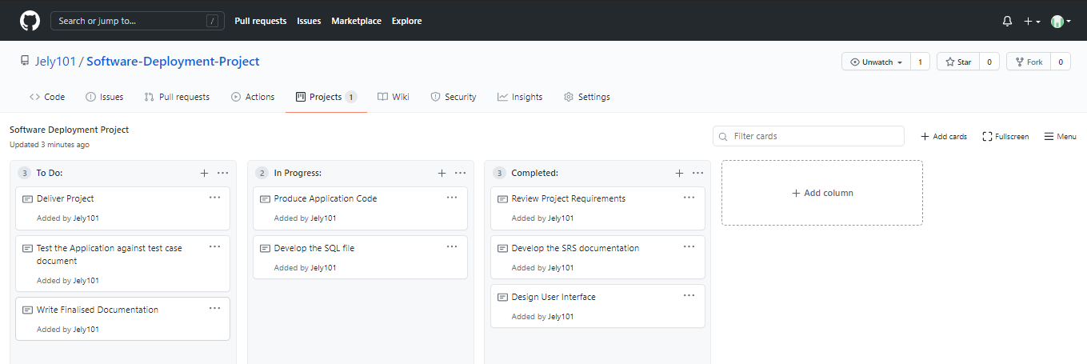

### SQL Statements

The following statements have been used to import the .xls file contents into the database.

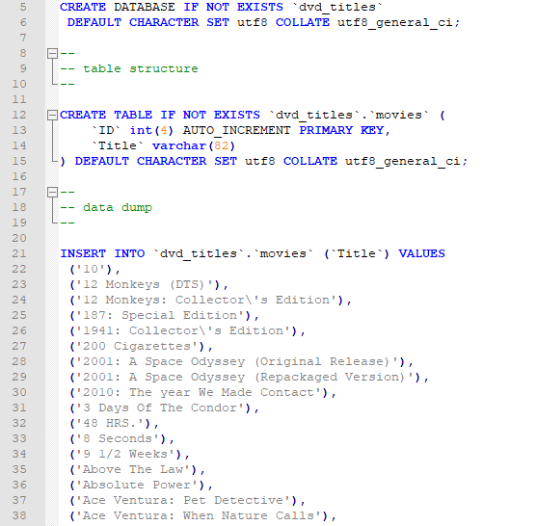

The amount of movie titles being inserted into the database is quite large so displaying the entire .sql file would not be practical.

# Activity Two Requirements

### Installation Method and Plan

Due to the application being developed using Java, the size of the associated files being used is quite small. For this reason it has been decided that the final version of the application can be provided to the client either by email, USB stick or via a password protected file hosting system. The files provided to the user will be an executable JAR file, as well as installation instructions and any files required for the deployment of a database.

The installation instructions will be quite simple but will provide step by step instructions to ensure the application delivered works as intended on the client’s computer.

1. Download and install XAMPP
2. Run the XAMPP control panel within its file location
3. Start the apache and MySQL options within the XAMPP control panel
4. Open an internet browser and enter http://localhost/phpmyadmin/index.php
5. Select ‘New’ in the left side navigation menu.
6. Select the ‘Import’ tab in the navigation menu near the top of the screen
7. Select ‘Choose file’ and select the ‘dvd_titles.sql’ file supplied to you.
8. Select the ‘Go’ button at the bottom of the page.
9. Close the browser window.
10. Open the ‘Movie Search’ folder provided to you
11. Double click on the ‘MovieSearchApp’ file

### System Requirements

In order for this application to run effectively the following system requirements were determined by first gathering the minimum requirements required to operate a windows 10 operating system. Even though the application requirements are much less than the minimum listed, a windows operating system is required to run this application.

Minimum System requirements:

* Processor (CPU): Intel core 2 or equivalent
* Operating System: Microsoft Windows 10
* Memory: 2 Gb RAM
* Hard Disk: 5MB free space
* Display: 1280x 768 monitor
* Graphics: Direct X 9 or later

Client PC system requirements:

* Processor (CPU): Intel(R)_Core(TM)_i7-4820K_CPU_@_3.70GHz
* Operating System: Microsoft Windows 10
* Memory: 16 Gb RAM
* Hard Disk: 1Tb HDD
* Display: 1280x 768 monitor
* Graphics: NIVIDEA GeForce GTX 780

### Installation Package Development

The executable JAR file was created using NetBeans. After the application was completed, right clicking on the MovieSearchApp package, and selecting Clean and Build. This will create a dist file which contains the executable JAR file as well as any libraries needed for the application to run. After this file was created I inserted the installation help file , along with the .sql file providing the user all the files required to get the application running.

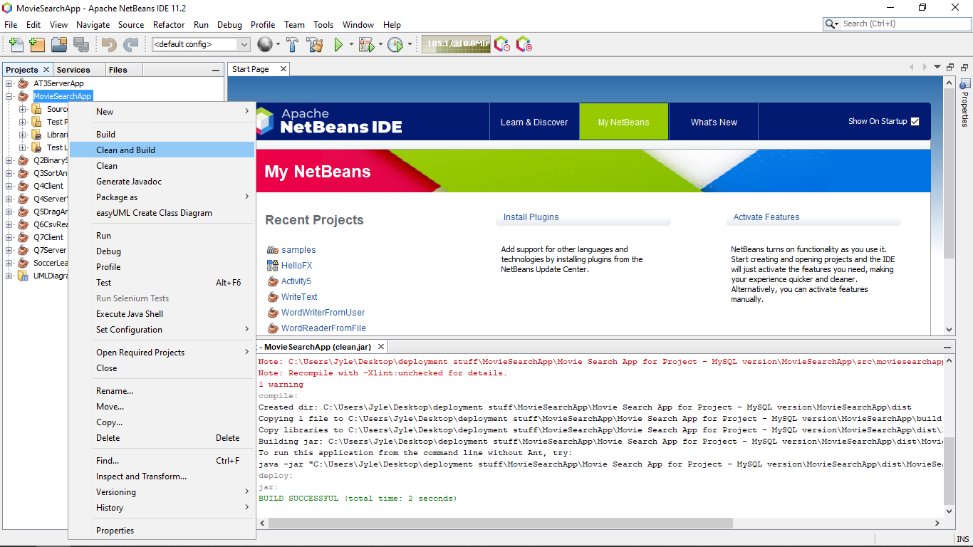

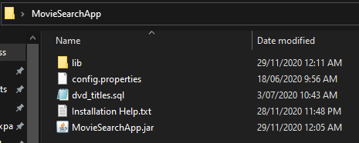

### Demonstration of the Application Installation

The application was tested by adding all the required files to a USB Drive, the drive was then used to transfer the files to my partners laptop. The instructions were followed provided in the Installation Help.txt file and the application ran successfully.

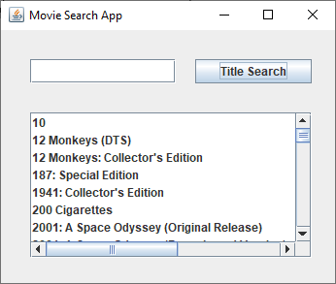

### Demonstration of the Application Uninstallation

The application was sent as an executable JAR file, so apart from the files provided to the client being saved onto the client’s system, no other files are installed, as the JAR file runs in its own Java Runtime Environment(JRE). To remove the application from the users PC, the user would simply have to delete the folder system containing the files required to run the application (i.e. MovieSearchApp folder).

### Database Deployment

The database is deployed to the client’s system via the included ‘dvd_titles.sql’ file. The client follows the instructions provided in the ‘Installation Help.txt’ file which will deploy the database, the database table and the table items required for the application to run effectively.

### Application Configuration

A configuration file is included within the files supplied to the client. This file is required for the JAR file to function correctly as it contains the variables used to connect to the deployed database. This file is included to provide the client the ability to import the .sql file into a different database management system, while not needing to change the application code.

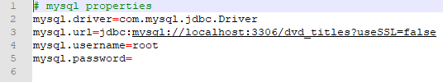

### Security Features

It was determined that because this application is deployed directly to the client, for use on the clients personal computer, no significant security features are required for this application to function, outside those that the client computer system would already be employing.